|  |  |
| --- | --- |
| Case Study | “People in both fields operate with beliefs and biases. To the extent you can eliminate both and replace them with data, you gain a clear advantage.”  ― **Michael Lewis,**[**Moneyball: The Art of Winning an Unfair Game**](https://www.goodreads.com/work/quotes/416305)  Tony Trotter  Finance 6220 |

1. My analysis concludes that the capital budgeting process *does* support Target’s strategy of “opening approximately 100 new stores a year while maintaining a positive brand image.” As evidence of this, I would point to the fact that five of the ten top executives of Target are members of the CEC including the Chairman and CEO, the President, and the CFO. This indicates an alignment of interests within Target’s upper management and the capital budgeting process overseen by the CEC. Additionally, the frequency of CEC meetings is an evidence of the importance placed on the duties of the CEC by upper management.

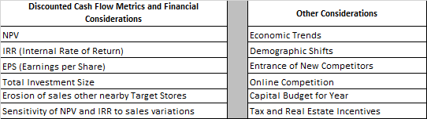Also, in determining the suitability of the various projects that are brought before the CEC, it is required that projects meet a variety of financial objectives, including but not limited to discounted cash-flow metrics and other financial considerations as listed in the table to the right:

The problem is that Target’s strategy should explicitly be focused on increasing shareholder wealth instead of just growth and brand image. This causes instances where pursuing growth may not always maximize shareholder value. These instances are quoted from the text below:

* *“In the rare instance when a project with a negative net present value (NPV) reached the CEC, the committee was asked to consider the project in light of its strategic importance to the company.”*
* *“In some cases, new Target stores were strategically located to block other retailers despite marginal short-term returns.”*
* *The CEC should worry less about Whalen Court’s uncertain sales and focus more on the project as a means to increase Target’s brand awareness in an area with dense foot traffic and high-fashion appeal.*
* *The NPV, however, was small at $317,000, well below the expected NPV of a Super Target prototype and would be negative without the value contribution of credit-card sales.*

My recommendation is to have Target restate its strategy emphasizing the increase of shareholder wealth *through* aggressive store growth and maintaining brand image. Additionally, if instances arise wherein projects are suggested for their *strategic* and/or *brand-awareness* value; I would recommend that the CEC demand that these qualitative factors be quantified and be included in the NPV calculations that are part of the Capital Project Request. If after these changes are implemented there are instances where projects are being considered with marginal or negative NPVs; I would recommend that those projects be declined.

2. To compete with Costco, Target offers credit to qualified customers through its REDcards: Target Visa Credit Card and Target Credit Card. From the case we read:

“The credit-card business accounted for 14.9% of Target’s operating earnings and ***was designed to be integrated with the company’s overall strategy*** by focusing only on customers who visited Target stores.”

Each additional Target store creates cash flows from store operations, but it also gets incremental cash flows from Target’s credit card business. Generally, a hurdle rate is assigned to determine the net present value of future cash flows based on the risk of those cash flows. Regarding Target’s REDcard cash flows, the case reads:

“...different discount rates were chosen to represent the different costs of capital for funding store operations versus funding credit-card receivables.”

It is appropriate that a lower hurdle rate be used for Target’s credit card cash flows because of the different set of risks associated with those cash flows. i.e., operationally, to be profitable a store must contend with:

|  |  |
| --- | --- |
| * ***Employee theft*** | * ***Inventory spoilage*** |
| * ***Facilities maintenance costs*** | * ***Increased competition*** |
| * ***Demographic shifts*** | * ***Customer theft*** |

As the credit card business does not have the same fundamental risks as a Target store, it is appropriate to discount the incremental cash flows associated with that business at a rate that is proportionate to those risks, and in this case that rate is 4%.

3. The Goldie’s Square proposal should be rejected, because the NPV of the project is too low to absorb any deviation in sales to the downside (exhibit 6). Without real options being factored into the NPV calculation of the project, the base case NPV is not high enough to have confidence that a fast-growing population will translate into the sales as they are anticipated in the CPR. Additionally, the failure of a Super Target would be high profile and would tarnish the brand beyond that of a traditional Target store closure. To restate, the CPR does not sufficiently quantify the subjective aspects of the Goldie’s Square proposal, i.e., a fast-growing population, good brand awareness and sales growth. From the text, we read:

*“…Despite the relatively weak NPV figures, this was a hotly contested area with an affluent and fast-growing population, which could afford good brand awareness should the growth materialize.”*

A decision-tree, simulation or Monte-Carlo analysis that incorporated the impact that these effects would have on the project’s NPV would assist the CEC better evaluate this proposal. Without employing some method of looking at multiple future outcomes, this project should be rejected because of the low base-case NPV.

4.The option to expand, to abandon as well as the impact sales and costs variations would have on a project are incorporated into Target’s Capital Project Requests. However, these real options are not assigned a probability of occurrence. Quantifying the likelihood of these risks/opportunities would be necessary to accurately predict a project’s NPV under multiple future scenarios and would assist in maximizing shareholder value. As evidence of this, we read:

*“Smaller stores often offered a higher NPV; but the NPV estimate did not consider the effect of future upgrades or expansions that would be required if the surrounding communities grew, nor the advantage of opening a larger store in an area where it could serve the purpose of blocking competitors from opening stores nearby.”*

Additionally,

*“The analysis of a new store included incremental cash flow projections* ***for 60 years*** *over which time* ***the model included a remodeling of the store every 10 years****.”*

It is not possible to accurately forecast how something is going to perform 30+ years into the future without a tremendous amount of uncertainty. Thus, Target’s capital budgeting process is inadequate. It should calculate each NPV under the scenarios outlined in the risk/opportunity section of the CPR, assign a probability of occurrence to these NPVs, and then aggregate the probability-weighted NPVs to determine each project’s market value.

5. I would approve The Barn, Stadium Remodel, Gopher Place and Whalen Court.

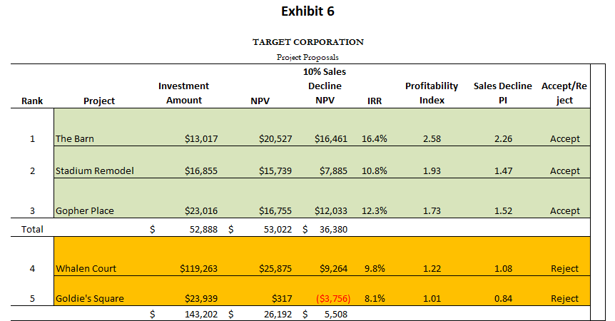6. I would use the profitability index to rank the projects under a capitol rationing scenario. The profitability index indicates that ***the Barn, Stadium Remodel and Gopher Place*** should be accepted, and Whalen Court and Goldie’s Square should be rejected.

Projects are ranked in descending order of profitability with aggregated Investment amounts, NPV’s and Profitability Indices listed in the table to the right:

|  |  |
| --- | --- |
| **Exhibit 1** | |
| **Capital Expenditure Committee Members** | |
| John D. Griffith | Executive Vice President, Property Development |
| Troy H. Risch | Executive Vice President, Stores |
| Douglas A. Scovanner | Executive Vice President, Chief Financial Officer |
| Gregg W. Steinhafel | President |
| Robert J. Ulrich | Chairman and Chief Executive Officer |

